An investigation into what consitutes e-pedagogy and e-learning

Abstract

The central theme of this paper is an investigation of what constitutes e-e-pedagogy and e-learning and it concludes with a model of e-pedagogy, with particular reference to the school environment. From a case study of the observation and description of a pupils’ online community, phases in the e-learning process are identified. A key theme is transformational learning. E-learning is seen as an emancipatory knowledge creation process, in which teacher and pupil interchange roles in a collaborative learning environment. The teacher as facilitator, guides the learners through the process of acquiring skills, to the collection of information, which is then developed into knowledge streams for group analysis. The internet offers a global information network and ICT hardware assists in maintaining an interactive learning environment. An important part of successful e-pedagogy is effective e-facilitation.

The key aspect of e-pedogogy is a transformational view of learning. It involves action and ownership by the learner. The teacher becomes the facilitator and the learner becomes the researcher. Online resources provide the flexibility and speed of resource access and response, required for individual and group knowledge construction. A word of caution though, with the proliferation of forums, email and online resource centres, teachers can be faced with a bewildering array of material and interactions. I think that the establishment of ‘portals of excellence’ will become important, such as the GTC site and Mirandanet, so they become a focal point for best practice, educational debate and gateways to other resources.

The literature that has influenced the design of the pilot study and my insights into elearning.

As a starting point for investigating the particular nature of e-pedagogy and the outcome of e-learning, it was important to have a view of pedagogy and the nature of learning that results from this. Open any dictionary and you will get a rather frugal definition of pedagogy, which states that pedagogy is the science or principles of teaching. For the purposes of this investigation the following more descriptive definition has been used, in order to investigate the processes and dynamics of teaching and learning.

‘Pedagogy is about the processes and dynamics of teaching and learning, including the purposes, relationships, environment, management and social context of learning.’ Sanguinetti,Waterhouse and Manders (2004).

A mechanistic view of pedagogy has dominated educational thinking for much of the twentieth century. Teaching is seen as the application of external cues and the transference of discrete bundles of knowledge. Whitaker (1995) states that there has been a tendency to view learning as something that educators do to us rather than as something we do for ourselves.

There is another, exciting viewpoint which provides a different lens for viewing pedagogy .I find the holistic, Transformatory Approach to teaching and learning described by Askew and Carnell (1998) particularly compelling. Right from the start of reading about this ‘philosophy of learning’ it seemed to strike chords with my own experiences of e-learning and e-communities and provide a basis for e-pedagogy provide a basis for exploring e-learning.

There is an interconnection between the emotional, spiritual, physical and the cognitive. The traditional approach to teaching and learning focuses almost entirely at the cognitive level only. The Transformatory Approach moves beyond individual cognitive development, to learning as a social event in a complex and multi-dimensional or possibly multi-media e-learning environment. If learning is to produce an effect on the individual, then this comes through a change in behaviour consequent upon a change in the meaning of experience. Positive outcomes occur when the teacher and the learning process connects with the learner’s context. Self is central, not the pedagogue. The learner impacts on the context and the context on the learner. And this it seems is what lies behind the whole of the DfES document ‘Towards a Unified e-Learning Strategy’. Technology can help us change the way we learn by making it more possible to place the learner at the centre, in a stimulating interactive environment.

Papert (1980) makes the point that we do not necessarily need a teacher – curriculum focused learning environment for learning to take place in our school. He points out that there is a capacity and desire for self-development, in all of us. This can be termed a self – actualizing tendency. My experience of online forums seemed to display many characteristics of transformatory learning and self – actualisation. This kind of learning environment offers the opportunities for learners to own the experience, as they construct knowledge, by interacting with one another.

These ideas were the spark which led to the development of an online forum to help my students develop their ideas about citizenship, as they felt that the traditional classroom environment was restrictive. The epistemology of the Transformational approach to learning provides a lens through which one can view the processes involved in elearning. The learner after acquiring access skills moves on to becomes a member of a collaborative learning environment, to become a facilitator and researcher with others, to construct knowledge.

I found that Askew and Carnell (1980) also had some valid points of advice for e-faciltators.They describe the skills of negotiation, conflict resolution and risk taking as crucial activities to bring about changes in a group. It is this list that reminds me of Tuckman’s storming, forming, norming, performing phases of group formation. I find this a useful mental image to have in mind as a facilitator, as one nurtures a group and develops it towards its goals.

The following points made by Askew and Carnell are particularly pertinent, and these feelings were the first thoughts of the participants in the forum I formed for the research assignment.

‘Clearly learners must feel that they are in a safe environment in order to perceive the learning to be enhanced. Perhaps not so obviously, they must also perceive the learning organisation as one in which risks are possible.

‘….learners must believe that their ideas will be honoured and valued and their failures will not be ridiculed. ….closely related to a sense of psychological safety is a sense on the part of the learners that they are accepted by their teachers and peers. ‘

‘In a successful group, learners have support and encouragement to take risks and make changes, be dependent, independent and interdependent’

And one could add here, be allowed to interchange roles between learner, researcher and facilitator.

So in designing a learning environment, consideration of how to produce a safe atmosphere which encouraged participation by members of its community, was an important issue. I wanted to establish some ethical framework for an on-line forum which was going to be the focal point for this investigation into e-learning. Norbert Pachler at the Institute of Education, London has put together a series of articles for forum facilitators wishing to learn more about developing codes of conduct for these learning environments.

In the online writing course http://www.ioe.ac.uk/schools/clc/pachler/writing-workshop/ethics.html, Norbert Pachler’s cited a series of references which provided food for thought, when setting up an online forum. Of particular relevance was Knobel’s (2002) article on research ethics. He makes the point that one must study the ethical issues right from the start. His maxim of ‘Do no harm, be informed, honest, open and be prepared to practice an ongoing reflection of the research process’ has been instructive. When designing my own research project, initial discussions with participants on privacy and whether postings should be anonymous were issues which were at the heart of determining whether participants felt safe and able to contribute. These discussions led to the development of a Code of Conduct being established, agreed by all participants and providing a learning environment they felt happy with.

Salmon(2002) has also had a central role also in developing my thinking about e-learning. She has formulated an e-learning model which goes through a series of phases, which I have recognised in my experiences of participating in GTCE forums. The model moves through access, socialization, information exchange, knowledge construction and development. This has been a helpful framework to use when first establishing a forum, for use with pupils and staff in my own school. However there are some modifications that I would make, particularly in relation to the school context. Firstly there is not enough emphasis in the model about the changing nature of the learning process. One must spend time setting up a collaborative learning environment and this is an extension of the socialization phase in the Salmon model. In this phase of the process, the participants are learners, taking on the access skills and developing communication skills in an ‘unfamiliar medium’. The Salmon model

needs to address the transformation that occurs as the collaborative learning environment enables the learners to become independent, analyse the information available to them and generate knowledge streams. In this way participants become researchers and as they interact with one another to develop ideas, they become facilitators.

In another way Salmon does not address the issues of establishing forums amongst academic staff, where there is no imperative of a course or qualifications to be obtained. In setting up a departmental forum for staff to exchange views, one needs to ‘market the forum’. People need to have a reason to visit a forum. What are they going to get out of it? An initial phase of ‘marketing’, could be considered to describe this.

Observing and describing the process of using an online pupils’ community

Context of the study

After participating online in GTCE forums and looking at the model of e- learning for online community that Salmon (2002) has put forward, I wondered how the processes compared with similar communities in schools. Salmon’s predominantly university, distance learning environment and the GTCE forums were very different in many aspects to that found in the secondary school. Would an alternative model emerge?. There is another strand to this project. Askew and Carnell (1998) talk about Transformatory Learning and seem to offer a lens through which to view e- learning.

And so the story begins with a year 9 class coming into my classroom after a presentation on citizenship. Instant feedback showed that they were frustrated by the lack of opportunity to discuss the meaning and value of citizenship at their own pace and in smaller groups. The group of 12 pupils were keen to explore their ideas. An online forum offered them a means to investigate their ideas, in their own space and preferred pace. The subject for investigation and the title of the forum was ‘The Meaning and Value of Citizenship’

The Research Question

The central research question is what constitutes e-learning?

What constitutes e- learning?
In recording the learning process and its outcomes I was looking for any patterns or reactions from students, which differentiated this kind of, learning environment. What might be the ‘e’ be?

To study this a research project was undertaken to investigate the processes involved in an online forum of secondary school pupils. There are a series of sub:questions.

What are the processes involved in setting up and running an online forum?
This is the first online forum that has been constructed in the school where this research has taken place. In observing the processes that the project goes through, the aim is to model what happens, and use the observations to assist staff who would like to use this learning environment.

How far do the processes match the Salmon model?
The Salmon model is a five stage model for online discussion forums, which runs through
Access,
Socialisation,
Information exchange
Knowledge construction
Development
Developed in a university, distance learning environment, it is interesting to observe any modifications that will need to be made for the secondary school context of this research.

Methodology

A questionnaire and mind mapping exercise was given to the students at the start of the project to survey the following:

The questionnaire surveyed the pupils' views on face to face discussion of citizenship issues and why this had not been successful in their opinion.

Pupils’ knowledge about the meaning and value of citizenship was captured on mindmaps before the online discussion group was created, to create a baseline set of data for comparison at the end of the project. In this way one could sense any additional learning that taken place during participation in the forum.

A questionnaire and a mind mapping exercise was given to pupils at the end of the project to obtain data on the following;

The questionnaire asked pupils their views on the online forum, how effective they felt it was and how it compared with the face to face sessions they had in discussing citizenship.

Pupils recorded their knowledge about the meaning and value of citizenship using a mind map and these were compared with the maps created at the start of the project.

Setting up an online forum

Logistics.
A closed forum was set up at www.mirandanet.ac.uk.
Access was restricted to the project group, all of whom were given a password when they first logged in with their email address.
All participants could opt to receive replies to their postings by email.

Ethical considerations

There were a number of issues regarding the conduct of the online discussions that were considered before starting up the forum.

The articles from an online workshop about the ethics of on-line learning environments by Norbert Pachler,http://www.ioe.ac.uk/schools/clc/pachler/writing-workshop/ethics.html, provided a synopsis of some of the issues, which can be summarised as:

Privacy of responses for the participants
Ownership of the research material
Whether a Code of Conduct should be adapted

A closed forum was chosen so that individuals could feel safe that their contributions remained with the group. At each stage the aims and the outcomes of the research project was outlined to the participants and their permission was sought to release information coming out of the study.

Discussions with colleagues on the GTCE e-facilitators website provided useful insights.

A sample of these discussions is shown below.
My posting
When setting up a forum with my own students for my research project, the first thing they asked about, were the 'rules of engagement'. They wanted some rules to be posted before they started about respect and in addition they wanted everyone to be clearly identified.
John
I feel that your last paragraph is absolutely critical. If any discussion is to be taken seriously then all participants have to be accorded respect.
Without your rules of engagement this can't really happen.
Peter
This is interesting. I feel that Codes of Practices should be adopted. You may lose some people and some discussion, but if people have something to say, they will say it. The environment is a safe one, and people will not feel intimidated by being in this area.
So rules of engagement are essential for a decent discussion forum.

John
Ask the students to come up with a list of five rules and use those.
Then they can monitor postings themselves. It's a highly relevant issue for Citizenship.

A discussion with the pupils participating in the project brought two points. It was agreed that anonymous postings would make the whole process rather sterile and further divorced from normal conversation. So the decision was made to use identifiable names or abbreviations in the forum. We decided to develop our own Code of Conduct through discussion online.

4. Facilitating the discussion forum and observing the processes
The forum ran for a period of four weeks and it was titled ‘The Meaning and Value of Citizenship. I facilitated the forum. To capture the processes of using an online pupil forum the following techniques were used.

An e-facilitation journal was kept to record thoughts, issues, problems and attempted solutions.

Archived discussion log of the forum for later analysis

Outcomes

1. Processes of setting up and running an online forum

The life of the forum progressed through the following stages;

a. Getting pupils on line

Once the forum had been set up by Mirandanet, participant logged in and received their password. On entering the forum they found a welcome message, shown overleaf.

Author: Michael Smith
Date: 09-15-03 21:58
Well done for signing on and agreeing to take part in this forum.
We will be investigating Citizenship and what you think it means and why it might be important to you.
First off though, to many, of you discussing ideas in an electronic forum is new . Many of you have suggested that we need some Rules of Conduct. So I would like you to suggest some ideas so that we can work towards an agreed set of guidelines for our online community.
To start you off here are some ideas...
We should use our real names when logging in for discussions in this forum.
This is a closed forum and is only open to the students I have already mentioned to you or to other that we as a group would like to invite.
So there you are what are your ideas on the Rules of Conduct?
There were some members of the group who started straight away and other needed some encouragement and training to show them how to log in as the following entry from the e-facilitation journal describes.

Extract from E-facilitation journal.

24th September 2003

So the journal has been running a few days now. Although advertised in class I had to get pupils to log in during class time. There. Are still a few more to get going. Plenty of promises to log in at home but no a great response yet. Still, four people have made postings.

My role to date has been to encourage, welcome, congratulate.
It is important not to keep a thread open too long. Change topic name and summarise as you go along. Try and keep things moving. Use questions to offer new avenues of approach to the forum members.

To date we have some simple rules of conduct and this was a useful neutral area to form a basis of discussion for the group. It was important part of the precess and even requested by some although others have asked to move on to the central questions quickly.

Even in cyberspace the attention span of adolescent boys is short!

b. The Rules of Conduct
The group discussed the concept of rules of conduct and a consensus opinion produced the following code;

Respect the views of others in the forum
Do not be rude or swear
If you disagree with what has been said, be polite when you reply
Try not to digress from the subject matter of the thread

c. Mentoring, encouraging, question setting

In the early stages of our forum, the teacher acted as a mentor and facilitator and this can be illustrated the discourse in extracts 1 and 2 below. The participants are learning the skills of forum discussion; they are being encouraged to unfreeze their ideas through the setting of challenging questions.

Extract 1
c. Welcome Sanj and Alex, thank you for your contributions. If you go to the new thread on Rules of Conduct, so far... you will see a summary of where we have got to. Your comments will be most welcome.
You have to be a careful not to trivialise the debate. Do you think it is part of citizenship to seek retribution, or rather to use the existing legal framework to seek justice?
Extract 2
Is citizenship an impossible ideal or a useful model for lifeAuthor: Michael Smith
Date: 09-25-03 17:46
bishai made an interesting point. He feels that as we are not perfect beings it is impossible to aspire to true values for everyone.
I agree that whatever virtues you wish a society to aspire to, some perhaps many may not follow or adopt them.

However, do we feel that citizenship - or the values of being a citizen might provide a useful model for living?
If so what might be useful values to aspire to?

c. Information collection to sharing knowledge streams
As the online discussion progress a large amount of information on views and ideas is collected. This needs to be summarised by the forum facilitator, or as participants become more used to the forum, they do the summaries and this is illustrated by the pupil posting in extract 3 below. Here the participant has become a learner and a facilitator, considering the information collected, sharing a viewpoint and drawing out streams of ideas.

Extract 3
Re: What do you think Citizenship is? Author: Wesley
Date: 09-24-03 19:30
I think citizenship is about any action you make that benefits your society and contributes to it, i.e "being a good citizen".
However, I suppose that what I have just said is probably flawed as what you perceive to be "good" may not be to another person, or doing one thing will benefit some people, but may not others.
Perhaps deciding what is or is not a "good" action depends on a mixture of both your perceived views and intentions and the perceptions of the people you affect.
What do you think?

d. Knowledge creation and reflection, an iterative process

As the life of the forum matures the participants are constructing knowledge about the topic under discussion. Extract 3 shows how they are interacting with other viewpoints and reflecting on their own ideas, in an iterative manner, refining their understanding. At this stage the teacher facilitator has now become a learner as well, entering into the reflective debate. More importantly the participants are now facilitators, asking questions of others, and pushing the debate forward as researchers.

Extract 4
Re: The discussion centre for 6-11th OctoberAuthor: talat
Date: 10-08-03 11:49
I disagree with Alex to a certain extent:
it is as a result of the interferance of MEDC's that has caused 'the war against terroism'. Although they showed there intentions as being good, it is possible to notice that millions of lives have been affected in good ways but many have been affected in bad ways. Would you consider the 'help' from America as being global citizenship.

2. A comparison of the online processes observed with Salmon’s five stage model.
Salmon describes online teaching and learning as moving through five stages, access and motivation, socialisation, information exchange, knowledge construction and development .In general the forum observed did follow a series of stages which involved issues of access, motivation, creating a learning community, leading to information exchange and knowledge development. However I believe that there are useful conceptual additions that should be made to set the model in the context of a school environment and a modified ‘School Model, shown below.

Modified School Model of elearning

Stage 1 Skills acquisition
Teacher transfers study and access skills
Teacher as instructor
Participants as learners
Stage 2 Setting up a collaborative learning environment
Teacher welcomes, encourages, mentors, question setting
Teacher as mentor and facilitator
Participants as learners

Stage 3 Information collection and sharing knowledge streams
Accumulation of ideas and data
Sharing of ideas
Summarising and the formation of knowledge streams
Teacher as facilitator, learner and researcher
Learner also becomes a researcher, pushing the process of learning forward with questions and analysis

Stage 4 Knowledge Creation and Reflection
This is an iterative process and involves the teacher and the participants operating together as facilitators, learners and researchers, with roles changing as the reflective process leads to knowledge creation and further knowledge construction.

Stage 5 Communicating the ideas

3. What constitutes e- learning?

a. What kind of learning development took place in the forum?
Capturing the views of pupils at the start of the forum on the ‘Meaning and Value of Citizenship produced the following definitions;

How to be good
How society works
How you should behave
About government
The laws we obey
People

The views expressed in answer to the same question, ‘What do you think Citizenship is? after the forum, bought a different style of answer. 90% of the participants wrote a sentence, rather than a phrase, with words such as moral value, responsibility and community or society.

A typical response was ‘ Citizenship is about being a member of a society and behaving in such a way that helps others and contributes your services to the society

The responses were confident and offered a more detailed response.

b. How does the experience of the online forum differ from face to face classroom learning?
Observing the online processes and recording the participants view the following points emerged about learning in an online forum.

- more relaxed, time to structure ideas properly

- slower in time but more efficient

- there is an archive to look back on picture

- allows for easier relaxing framing and reframing ideas

- calmer, perhaps less confrontational

- not as personal, however, the action of posting on line helps fix ideas and concepts in your mind.

a different learning culture which is focused on being a learner and constructing knowledge

- the action of posting ideas online assists in clarifying ones ideas and concepts.

- a richer learning environment in that it covers a wide range of higher ideas and skills than the traditional body of knowledge transfer type of learning.

I think e-learning can be viewed as a philosophy of learning. It is an emancipatory knowledge creation process, which empowers the pupils to own the process, by creating a collaborative learning environment, using electronic media to facilitate the learning process.

Conclusion :

E-Pedagogues

I have discussed in some detail my experiences of e-facilitation in this paper. In summary e-facilitators are multi-roled learning supervisors . They need to assist participants to become confident with the medium and the mechanics of online discussion forums. They are the glue which holds an e-learning community together, as well as the carer overlooking the birth, growth and final maturing of a collaborative on-line learning community. Finally they oversee the knowledge creation process, guiding the community to review and reflection on its discussions. There is one aspect that is not well discussed in the literature and that is the need to encourage participation.
In my experience, although email is generally a well used means of communication, familiar to many, the culture of an online community is less familiar. In this respect, as an e-facilitator one must ‘market’ a forum and work off-line to encourage and tutor potential participants.. And this leads to a final but important point, in a busy world, on-line forums must clearly indicate what participants might gain from a forum and they should also have a limited life, with regular outputs to encourage future postings by participants.

This set of processes can be thought of as a continuum. The facilitator is a mentor and a coach for members of the online community they are sharing dialogue with, identifying with that community, its purposes and developing the modes of communication. At other moments the facilitator is a shaper, moving discussions on and assisting the knowledge construction process. So one becomes at times a learning technician. Another part of the dimension of the role, is that of becoming a fellow learner, with the other members of the online community. The e-facilitator’s role is one of the e-pedagogues in the e-learning environment in which in a real sense all are teachers and learners.

There are some key activities that facilitators contribute to a an on-line learning environment:

- Aiding the knowledge construction process

- Summarising postings and moving discussions forward

- Helping new comers feel at home the in the discussion group by welcoming, encouraging and posting informative interactions.

- Becoming part of the online discussions as a fellow learner.

- Enable participants to write down their thought bubbles on the computer screen and break through the electronic barrier to sharing thoughts, ideas and knowledge on line.

- Attend to the silent visitors or observers (a better term, I believe, than lurkers), to assist them to cease floating and to come to rest as a posting.

- Possess an overarching or helicopter viewpoint and keep a focus on the forums aims.

- E-facilitators are vital to the life cycle of a forum or online course. They nurture the birth of an online community and steer it through its process to maturity, the conclusion of its purposes and the final archive

We are faced however with a proliferation of forums, email and online resource centres and learners can be faced with a bewildering array of material and potentilal interactions. I think that the establishment of ‘portals of excellence’ will become important, such as the GTC site and the Mirandanet community, so they become a focal point for best practice, educational debate and gateways to other resources.

.
What is e-learning : a model of e-pedagogy

The Smith Model (Figure 3) draws the strands of this assignment together. This model has been built up from observations from the research project, analysing my experiences and those of colleague investigating e-learning. It draws on the concept of the characteristics of a school as a learning organisation. (Askew and Carnell 1998 p 117)

- Knowledge is created by learning in different contexts and methods (multi media)

- Boundaries are blurred between the school and the external community (internet and video link)

- Roles are blurred and interchangeable

- The learning process is transparent, open and discussed

- There is a climate of high expectations, a collaborative process

The Smith Model for e-learning in Schools (Figure 3), builds on the Watkins model www.mirandanet.ac.uk/gtc/ (Figure 1 below, in which technology helps to bring learners together into a learning community.

In the democratic client - centred www.mirandanet.ac.uk/gtc/ (Figure 2), classroom is seen as a key element in transforming learning. This model I have drawn up shows how the learning process progresses through the stages of skills acquisition, information collection, through to knowledge creation and reflection. At its core is the development of a collaborative environment and the interchangeable roles of the teachers and learners.

This essentially therefore is the philosophy behind e-learning. It is a transformatory approach to learning. The students are empowered to own the process. Technology assists in developing a collaborative learning environment. E-media provide access to global information which through group interaction and analysis becomes knowledge, constructed and shared amongst the immediate group and with others through the internet. In this way we become global learning organisations
.

Figure1.Watkins Model 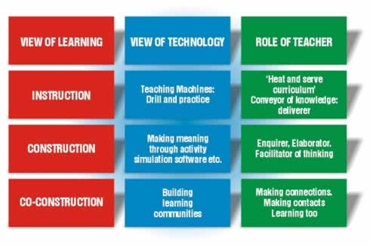

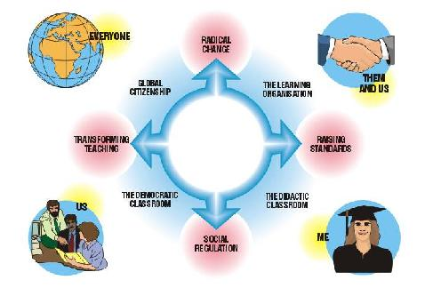
Figure 2 The Democratic Client Centred Model

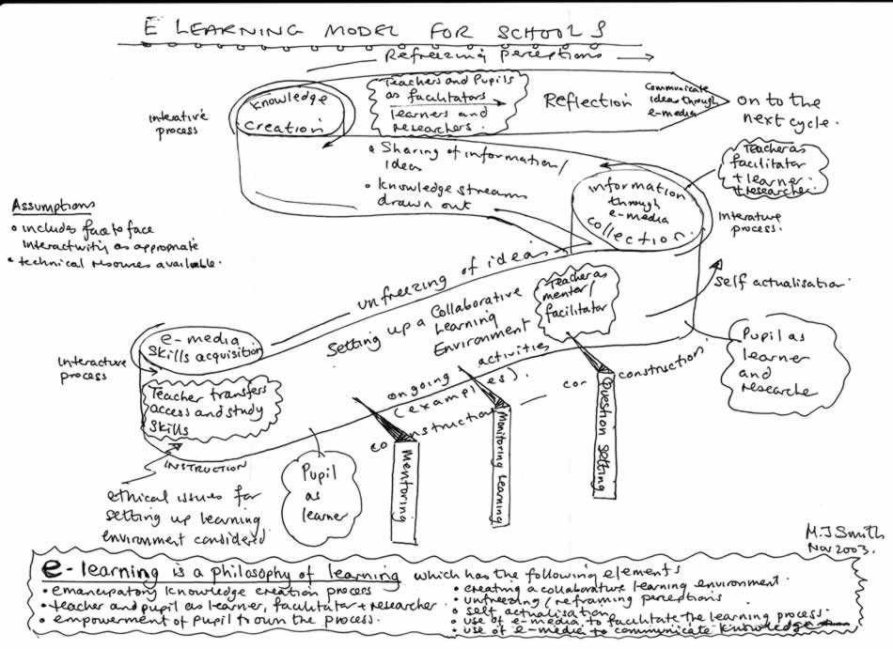

Figure 3 The Smith Model of E-Learning

Further work

Now that a framework for e-pedagogy and e-learning I am going to test its validity by running another in school on-line forum. I will be comparing the learning of two groups of students, one group will be using the forum as an integral part of their learning. Also I am going to investigate the impact of the introduction of an interactive intranet information system that has recently been installed in my school. In addition, as e-facilitation is a key role in e-pedagogy I will review the literature in this area with a view to building a model of the way in which this role impacts on learning.

BIBLIOGRAPHY

Askew, S and Carnell, 1989. E, Transforming Learning: Individual and Global Change, London, Institute of Education.

DfEE, 2003 Towards a Unified e-Learning Strategy, Consultation Document, http://careers.lancs.ac.uk/pb/docs/dfes-e-learningstrategy.pdf

Hopkins, D. 2002. A Teachers Guide to Classroom Research, , Buckingham, OUP

Mirandanet 2004 Ejournal www.mirandanet.ac.uk/gtc/

Pachler,N.2003,http://www.ioe.ac.uk/schools/clc/pachler/writing-workshop/ethics.html

Papert, S. 1980 Mindstorms: Children, Computers and Powerful Ideas. London, Harvester Press.

Preece, J, 2001, Online Communities, Wiley, Chester

Sanguinetti.J., Waterhouse.P. and Manders.D., 2004. The ACE Experience, Pedagogies for life and employability, page 7, Victoria Universityof Technology,Australia. www.acfe.vic.gov.au/news/pdf/The%20ACE%20Experience%20Pedagogy.pdf.

Salmon, G 2002. E-Activities, The Key to Online Learning, London, Kogan Page.

Whittaker,P 1995 Managing to Learn:Aspects of Reflective and Experiential Learning in Schools, Page 1. London, Cassell.

